

# LAB – FILE

**Graphics and Animation Tools - Lab**

**CSGG 4101**

Name – Rishank Gupta

Roll No. – R100217062

Sap id – 500062486

Course – B. Tech CSE-OSS

Batch – 2

*Under the guidance of…*

Dr.Durgansh Sharma

Associate professor

Department of Cybernetics

School of computer Science (Socs)

**Experiment- 1**

**Aim: - Installation of GIMP AND BLENDER.**

**GIMP installation Steps**

**Step-1: Download the GIMP installer.** To install GIMP on Windows, visit <https://www.gimp.org/downloads/>, and select the Microsoft Windows Platform. Consider the below image:

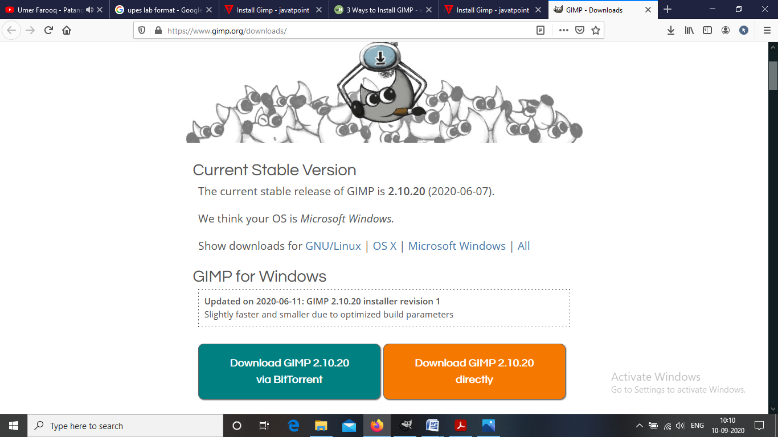

There are two download options available. Either we can download it via torrent or directly.

**Step-2: Run the GIMP installer.** It will be saved in your downloads section.

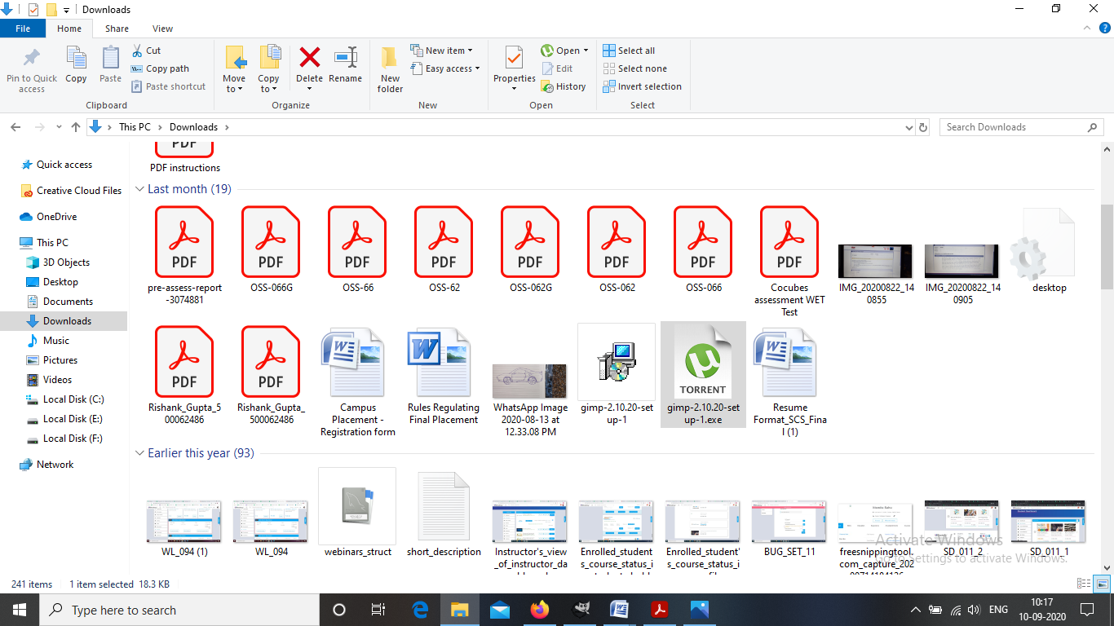

**Step-3: Follow the required prompt.** I leave them defaults and click on install.

**Step-4: Finish the Installation.** After selecting the file formats, it will take few minutes to install and then click on finish.

**Step-5: Start using GIMP.** Once GIMP is installed, you can start using it.

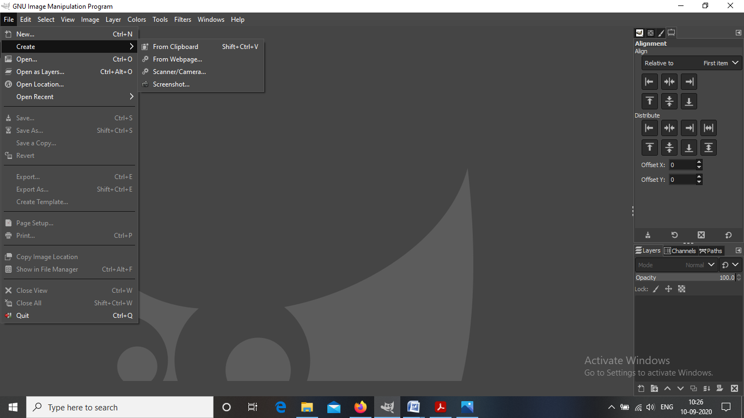

**BLENDER installation Steps**

**Step-1: Navigate to the Blender website.** [www.blender.org/](http://www.blender.org/)

**Step-2:** You can directly download the blender from here.

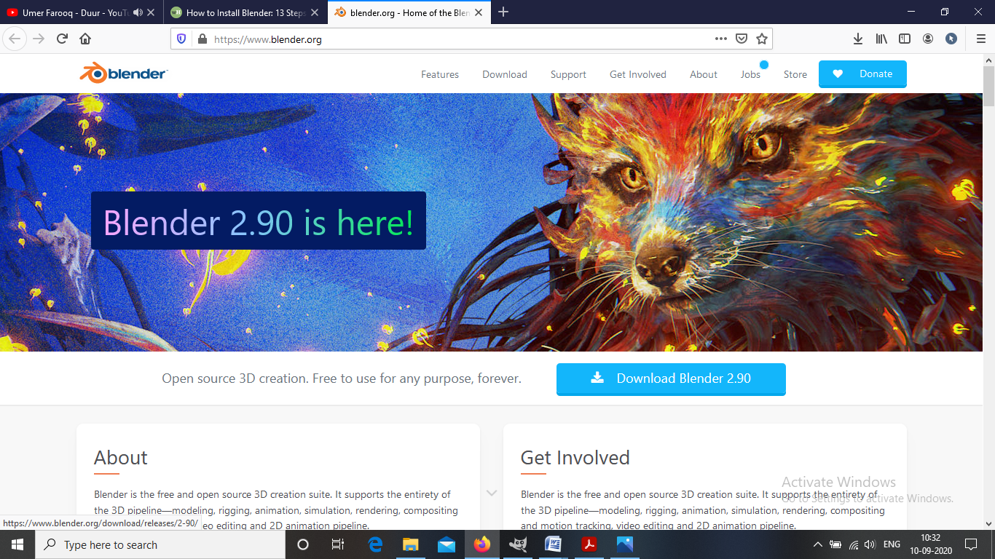

**Step-3: Run the installer.** It will usually be located in your download folder.

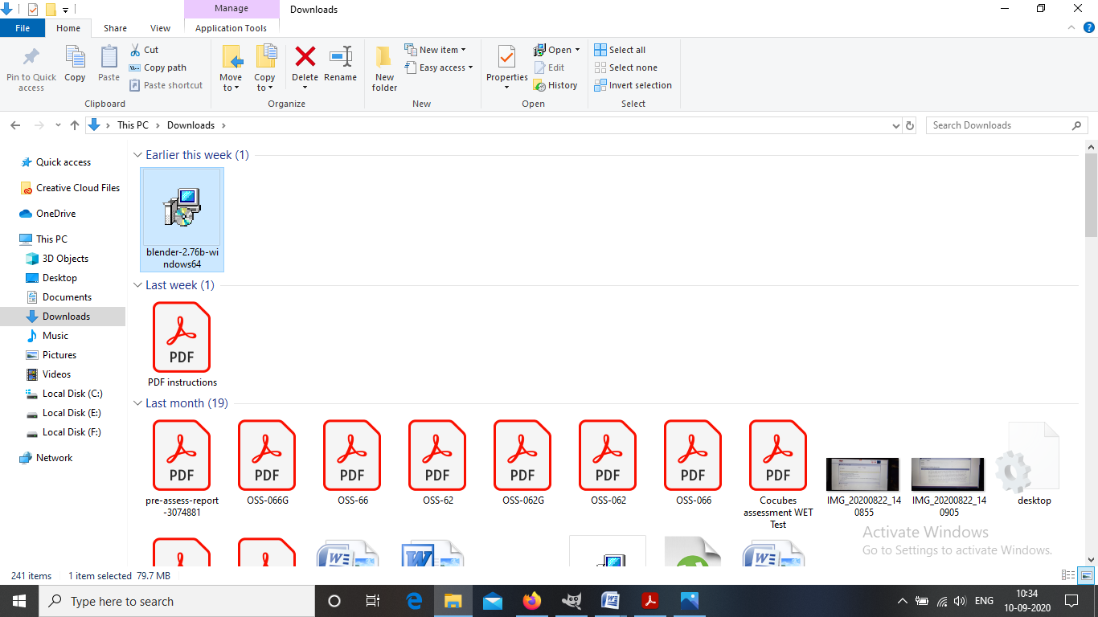

**Step-4: Start the installation process.** Click Next

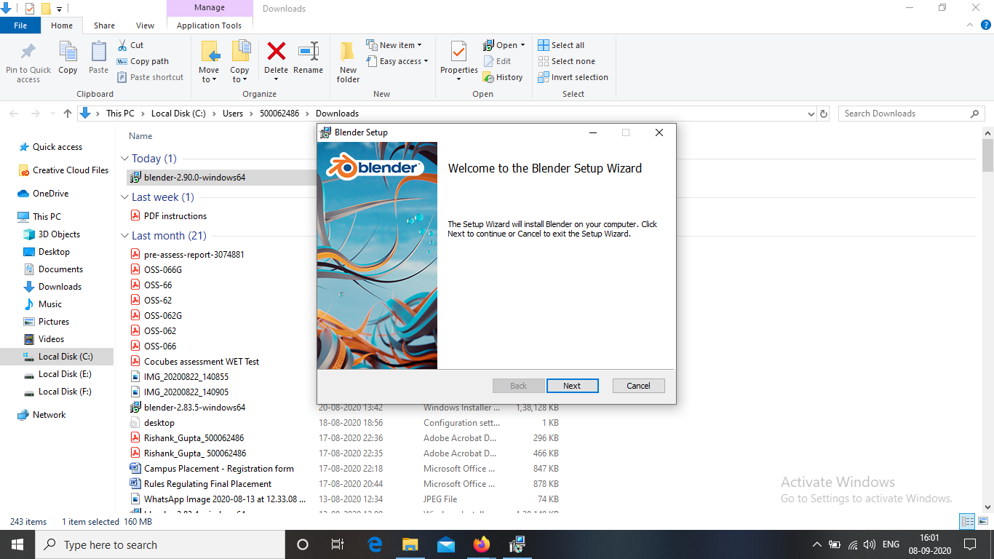

**Step-5: Agree to the Terms and Conditions.** When prompted, click I Agree in the installation wizard.

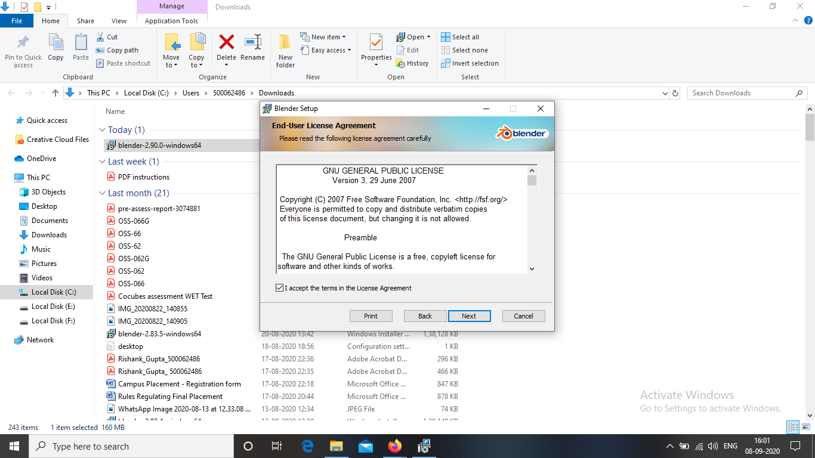

**Step-6: Choose a destination folder.** The default location is the Program Files folder of Drive C:\ in your computer. You may change the location of the application by clicking Browse.... Then click Install.

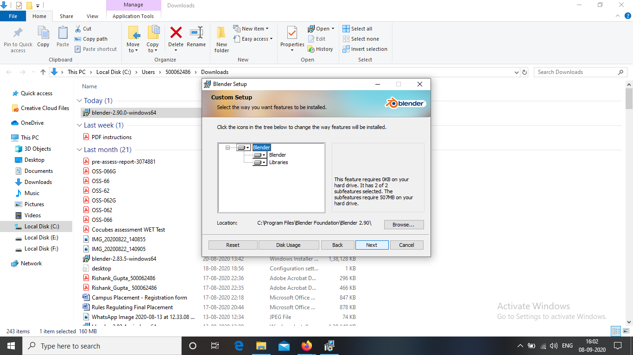

**Step-7: Finish the installation.** Click Finish when the installation is completed. Blender is now installed in your computer. You can start exploring the application when it starts automatically.

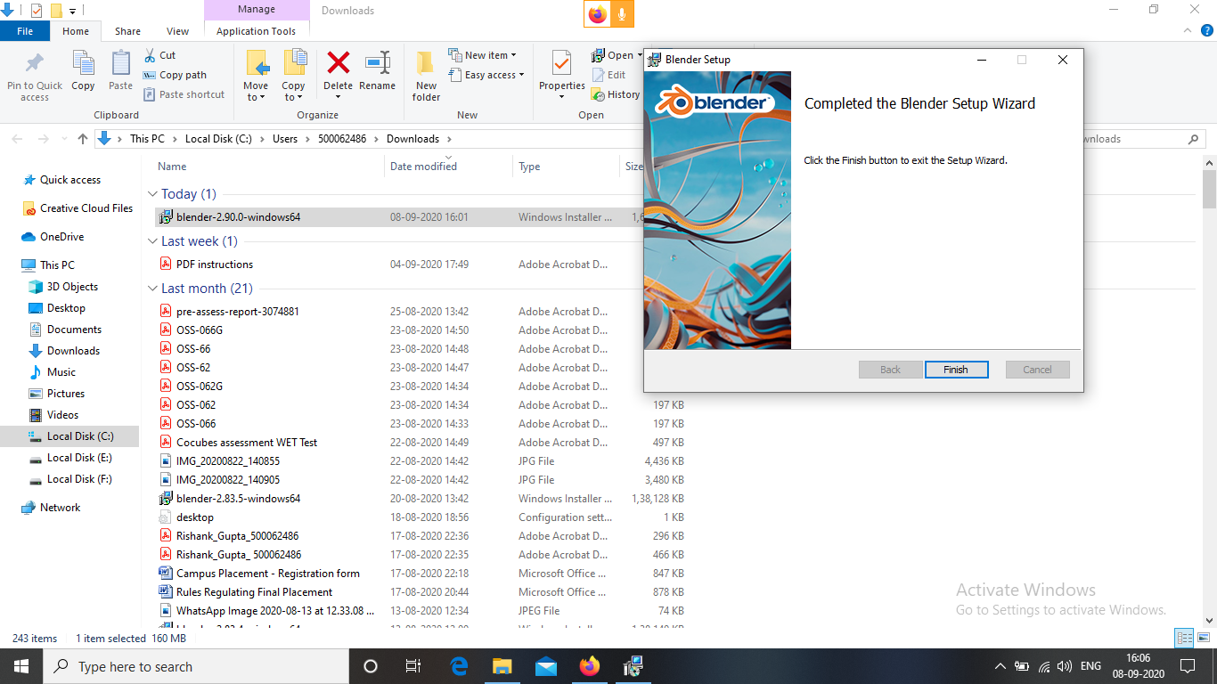

**Step-8: Now start using the BLENDER.**

